**Sample Project Report Format:**

**------------------------------------------------**

**Description:**

The aim of this project is to analyse and provide insights into India’s Transportation System.

India’s Transportation System include various modes of transportation services, from affordable prices to highly unaffordable prices. Modes of transportation differ in different provinces of India because of political, geographical, and other factors. India’s Transportation System includes buses, railways, aeroplanes, and many other small facilities like rickshaw’s etc. As India is a diverse country this project aims to show diversity in India’s transportation.

**Contribution:**

1. A webpage will be made using HTML, CSS, Hyperlink, JavaScript, and these functions will also be used to make animation, links, and buttons. These things will be performed by Manjot Kaur (811534)
2. Gathering relevant information and different kinds of videos, transportation services preferred by people in India, people views, expenses and various things will be gathered by Manjot Kaur (812955).

**Description of features:**

1. HTML: HTML stands for “Hypertext Markup Language”. It is a standard markup language used to create and design web pages and questions.HTML allows people to structure and format the content of a webpage and defining how the information should be displayed in a web browser. HTML uses various tags to describe various elements in webpage, such as headings, paragraph, images, links, tablets and more. These tags are enclosed between brackets and inform the web browser, how to read the content. <html> is an opening tags and </html> is a closing tag. There are total of 100 html tags and some of them are:

Head tag: This tag <head> contains all the elements describing the document.

Title tag: This tag <title> specifies the title of HTML page and this title is shown in the browser’s title bar.

Body tag: This tag <body> is where content of web page is inserted.

Paragraph tag: This tag <p> defines a paragraph on webpage.

Heading tag: This tag <h1> defines most important tag whereas <h6> is the least important.

Html is often used with CSS which are also called Cascading style sheets and JavaScript. This help in creation of interactive and creative webpages with different kinds of features.

So, the basic structure of HTML is,

<!DOCTYPE HTML>

<html>

<head>

<title>My First Page</title>

</head>

<body>

<h1>Hello</h1>

<p>This is my first webpage using html</p>

</body>

</html>

There is also a default site for the webpage which is called index.html. Index page is also commonly known as home page, as soon as user enter the information it will serve as starting point, and user will be provided with an overview of website’s content and navigation option.

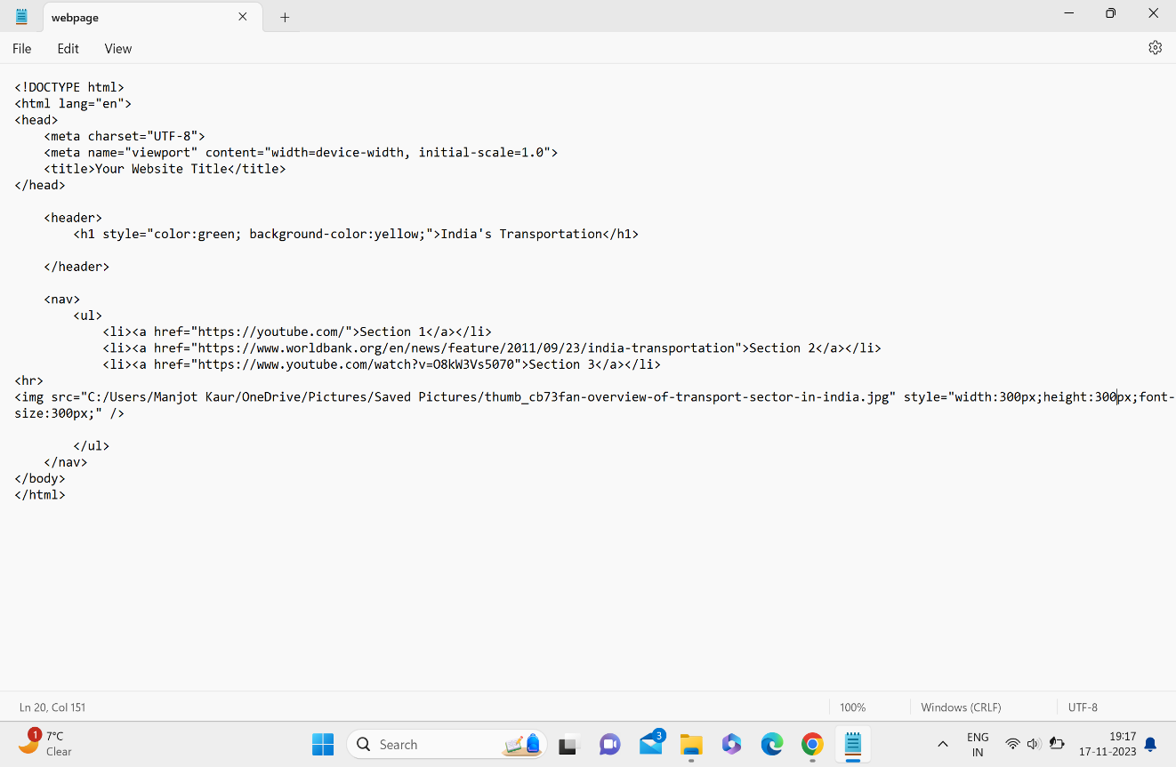

**CSS:**

CSS stands for cascading style sheets, and it is a programming language which is used in web development to control presentation and layout of the HTML documents. It defines how elements should be displayed on webpage like colours, fonts, spacing, positioning and other visual elements. CSS works with HTML and helps developers to style the elements consistently across different pages and devices.

Some commonly used CSS attributes are:

1. Color: It help to set the color of the text context
2. Font-size: It specifies the size of the font.
3. Font-family: It defines the font family.
4. Background-color: It sets the background color of an element.
5. Padding: It sets the spacing between the content and the border of an element
6. Margin: It specifies the spacing outside the border of an element.
7. Border: It defines the properties of an element’s border such as color, width, and style.
8. Width: It sets the width of an element.
9. Height: It sets the height of an element.

Use of CSS and html can be seen in a part of given below:

<header>

<h1 style="color:green; background-color:yellow;">India's Transportation</h1

</header>

This CSS property provide green color and background yellow to the heading India’s Transportation.

**JAVASCRIPT:** It is the world’s most popular language and is the versatile programming language that runs on the client- side (in the user’s web browser) and is used in conjugation with HTML and CSS to create feature-rich and responsive web pages. The role of JavaScript in a website includes the following key aspects:

The JavaScript code can be given as:

<button id= “myButton”>ClickMe!</button>

<script>

Document.getElementBYId(‘myButton’).onclick=function(){

Alert(‘Button clicked!’);

};

</script>

The above java script code will be used in our making of webpage we will add an on click button which by clicking will open into facts about transportation of India.

Java script helps the developers to use animations and visual effects in the webpage and this use of Java script can be see in our presentation also.

**HYPERLINK:**

Hyperlink in HTML play important role in connecting webpages and enabling navigation between different online resources. Hyperlink is link used in HTML and by clicking on this link user can transfer to different sites. The hyperlink has been used in making of our webpage in India’s transportation. The code is given below:

<li><a href="https://youtube.com/">Section 1</a></li>

<li><a href="https://www.worldbank.org/en/news/feature/2011/09/23/india-transportation">Section 2</a></li>

<li><a href="https://www.youtube.com/watch?v=O8kW3Vs5070">Section 3</a></li>

By clicking on these links user will be directed to sites containing information about India’s Transportation.

**CONCLUSION:**

This project made us familiar with HTML, CSS, JavaScript and gave us information to make webpage using the language because of which we were able to develop site on India’s Transportation System. By doing this project we will be able to design many web pages.

**References:**

[www.w3schools.com](http://www.w3schools.com)

[www.google.com](http://www.google.com)

[www.simplilearn.com](http://www.simplilearn.com)

[www.developer.mozilla.org](http://www.developer.mozilla.org)

<https://www.quora.com>

<https://www.javatpoint.com/html-tutorial>